MEAL PLANNER PROGRAMS
Interfaces DIRECTLY with:
Hospital Stock STOCK exe
Orders Manager OMENU2.exe

COPYRIGHT RESERVED

Windows 10
Written in Xbase

THIS MANUAL IS COMPULSORY READING!

Version September 2021*

These programs and manual are regularly updated.
This ensures that your investment stays up to date.

MealPlannerManual.doc

Table of Contents
General Information: 3
FURTHER INSTRUCTIONS 3
Common WINDOWS problems: 4
Starting for the first time 5
DEFINITIONS 5
GENERAL PROCEDURE: 6
Installation 15
APPENDIX 1 18
STOCK LOCATIONS 20
RECIPE CATEGORIES 22

General Information:
Password is ADMIN

Always check the date – it must be correct

Always close 0ORDER.TXT on the desktop
so that it may be overwritten with the new information.
0ORDER2.TXT for windows 8,10

Always check the Window’s desktop START bar (bottom of screen)
that the program is not already open. Always close programs by pressing 1 to Leave

Always close the program when not in use.

1. ALWAYS READ THE SCREEN & ANSWER THE SCREEN MESSAGES.
2 When starting for the first time - GO SLOWLY through the system.
Speed will be gained with experience.
3. "Enter": press after a value/name has been entered –
to move to the next field or screen.
4. All information, Eg names, should be entered in UPPER CASE (CAPITALS).
5. NO PUNCTUATION MARKS MUST BE USED (Eg no commas/full stops).
6. Printouts are printed on A4 size paper (Photostat paper).
7. Always have a spare ribbon, printer cartridge available.
Always have enough paper.
8. NEVER SWITCH OFF the computer before leaving all programs.

FURTHER INSTRUCTIONS
- Check the DATE and TIME on your computer.
  - Double-click the Clock on your Task Bar: check, change and apply .or
  - Go to Control panel : Select Date & time : change to the correct date and time.
  - Date and time must be correct.

- Always read the screen and follow screen instructions.

- “Enter” must be pressed after a name / value etc.
has been typed in, to move on to the next field or screen.

- Use “Page Up” and “Page Down” or the Arrow keys to move up and down through the files .

- All information, e.g. names and codes, must be entered in UPPER CASE
Caps Lock All information in Capitals & numeric 0 to 9 only.

- DO NOT USE any PUNCTUATION MARKS (i.e. commas, full stops)
Never use \ / ? * “ < > | , : in any code or file name

Never place spaces in the middle of a code e.g. PM1 003 I is WRONG.
(You will one day “forget “ that there is a space in the code and you will not find it!”)

PO BOX never P.O.BOX (remove the full stops )

- DO NOT CONFUSE: O for Oskar with 0 for zero (nil)
I for Irene with 1 for one
- ! for exclamation with 1 for one
Z for 2
B for Bert with “8”
\ = backstroke (on key below |) , Above the Enter key
please find it on your keyboard
With
/ = forward stroke (below? key) is never used
0 is not O = Zero is not O

Common WINDOWS problems:
Please keep your START bar at the bottom of your screen - never auto hide.
You need to be able to see all open programs on your Start bar
You should never open these programs more than once at a time

- Error BASE /8021 – unknown symbol for alias.
-Means Program already open – click on Meal Planner on Task bar – next to Start.
- “Sharing violation – work area already in use”.

MEANS: You are opening a program that is already open;
But it has been minimized & is already listed on the Start bar
i.e. so you have clicked on an icon that is already open.
Look in the START Bar at the bottom of your Desktop
– and you will see the program name, indicating that it is already open.
MP.EXE
Click on this program name to re-enter your program.

By carrying out the following procedures, Errors on the hard drive are fixed,
& the computer will run faster: therefore: Your hard disk will last longer

- Instructions for Windows XP & 7 : For improved performance, do the following
ONCE EVERY 2 MONTHS, or if you experience any computer problems:
select All Programs , Accessories , System Tools

Go to System Tools
and select
i) Disk Cleanup clears the rubbish off your computer
- empty “recycle bin”
- temporary files must be removed (select “remove temp files”)
- do NOT select “compress unused files”
ii) Disk Defragmenter puts all information on the hard disk in a straight line
If Defrag does not go to end, 100%, then your hard disk is broken
Never leave a program by using the mouse and clicking on the eXit, close X,
on the right upper side of the Window - the data files will be left open.
You will lose the last thing – information -you entered
Always only leave only by pressing 1 (one ) in the program so the program can close
the files before leaving.

Starting for the first time

The MEAL PLANNER consists of a screen (menu) from which other screens (menus) may be selected, by entering the relevant number(#) and pressing Enter.

DEFINITIONS:

INGREDIENT = STOCK
-A food item (stock item) that can be added to a recipe OR used separately in a
meal/menu.
-Stock items also refer to enteral feeding products, and also to disposable items, such
as paper bags, plastic wrap etc.

DELIVERY INVOICE
The invoice that is handed over on delivery of goods to the kitchen by the supplier. Each invoice has its own number, and the items delivered are listed with unit costs/item and the total costs indicated.

AUDIT
Track record of stock items (usage/rejections/delivery)

PURCHASE UNIT
The units in which ingredients/stock items are purchased.
For the purposes of this program:
Kilograms = KG e.g. meat
Liters = L e.g. milk
Each = EA e.g. apple

PURCHASE MASS
The mass of the ingredients to be purchased expressed in the specified Purchase Units.

STOCK STORAGE LOCATION AREA
Area of the kitchen (e.g. pantry/fridge) where a stock item is stored.
This area is used for stock taking purposes.

Password is ADMIN

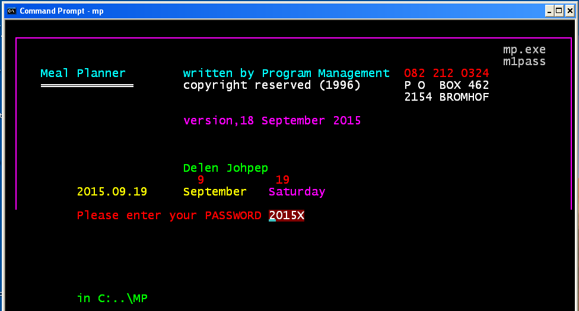

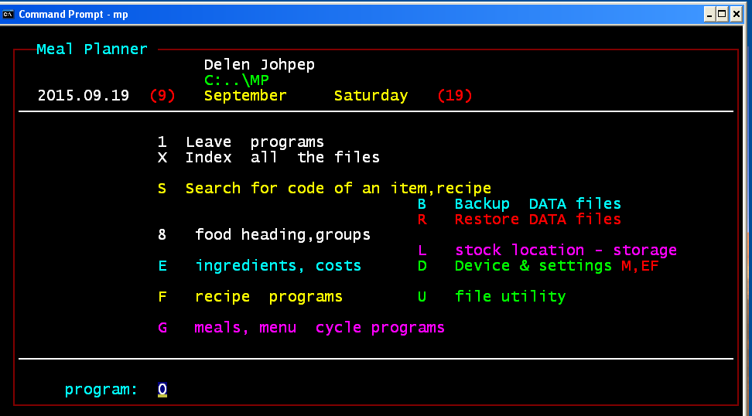

GENERAL PROCEDURE:

To enter the MEAL PLANNER, first enter the password: ADMIN

- To LEAVE the MEAL PLANNER programs & return to windows desktop:
Enter the number 1 then press Enter

X. INDEX ALL THE MEAL PLANNER FILES:
These files are then indexed for computer usage.
- This program automatically fixes many problems which can occur,
this reduces down time and to allows telephonic support.
- This is a major time and cost saving feature of the system.
- Should there be any problems, use this program, and then see if the problem is fixed.
- Use this program as often as you wish.
- V -Verifies food cost details. Only checks food with Stock Locations.

S. Search for code of an item, recipe
-Use this to look up a code of a food, e.g. for beans code, enter BEANS.
-Enter spaces into the food to leave this program.
-It will give the code, description, cost, quantity in stock, units and the stock location.
How to Search for a code on the file,
e.g. for beans code , enter BEANS
Enter spaces into the food to leave this program.

Enter the food RICE
Finding RICE Cost Qty Storage location,unit,unit mass
0108 MAIZE RICE Q: -8 02A
0124 RICE CRISPIES Q: 7 01A
0126 RICE, WHITE 01J
1912 SAVOURY RICE FLAV. 02G

“ “ enter a code or Press any key to continue...

B. Backup food costing files

Daily(when in use)
Backs up to the hard disk, or selected drive letter,
i.e. E, F for memory sticks or C for the Hard Disk.
Or you can go to “Computer “ find the \mp
And right click on \folder MP and “send to” memory stick

Weekly(when in use)
All files, in other words the whole folder (programs and data), need to be Backed up
to a different removable device.
-Close the program.
-Right-Click on the Meal Planner icon.
-Select “Open file location”
-Now if you are redirected to a Search Page
(IF YOU ARE NOT DIRECTED TO A SEARCH PAGE
SKIP THIS STEP),
Right-Click on the file “MP”
and select “Open file location” again.
-You are now in the MP folder.
-Hold CTRL-A, Right-Click the highlighted files and select “Send to”, then
select the name of your memory stick.

R. Restore data food costing files
-If data is lost or corrupted use this to copy you backed up files(DBK) to your current files(DBF).

G. Meals Menu cycle programs
This is where the meals are added to make up the menus.

E. Ingredients, costs
Here you enter the food the food and stock details and the recipes.

8. Food headings, groups
Enter the food headings. This program is the same as on the order side.

D. Settings
D-Device settings- Memory-E,F,G & Printers-M

V- Clean folder- Clean the MP folder of all the rubbish files
P-OFPAR- Change the user name
Z- Take out Costs- make all costs Zero 0.00

F recipe programs
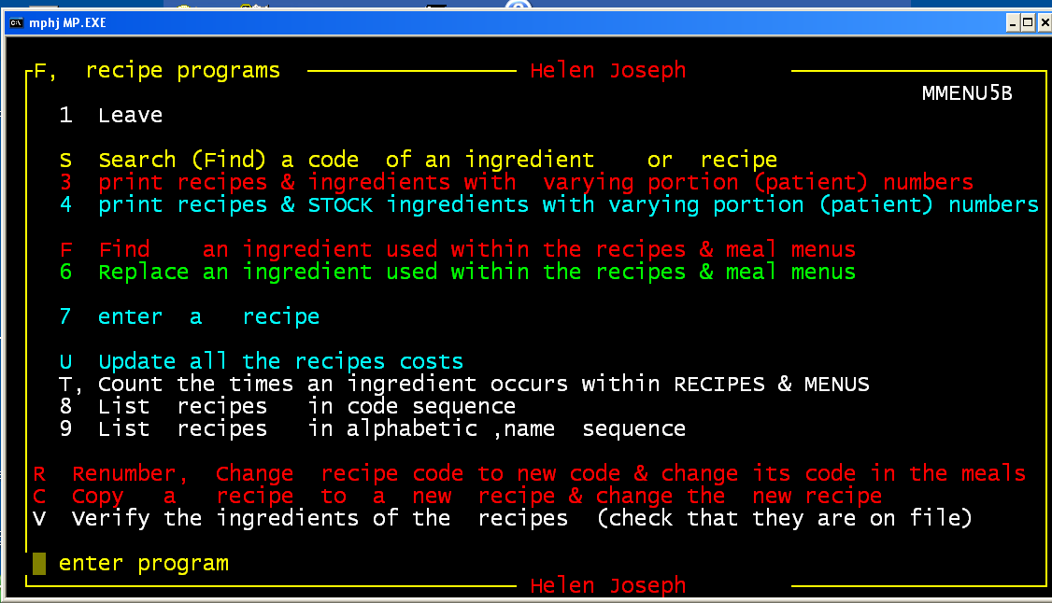

In this application you are able to:
-Enter new recipes.
-Find food items so that a meal may be entered.
-Count the number of times an ingredient is used in a recipe.
-You can also find ingredients that were used in different recipes.

- Print all the recipe with their ingredient codes
It includes the portion number, Starting printing from, Stop printing at.
Recipes are entered per hundred portions.

- Print all their recipes with their stock ingredients(Stock Codes)
It includes the portion number, Starting printing from, Stop printing at.
Recipes are entered per hundred portions.
- Find an ingredient code used within the recipes
e.g. If you need to find which recipes use egg, enter your EGG code.

- Replace an ingredient used within the recipes and meals
With other ingredient/(s), make sure of the replacement code.

- Enter a recipe
Enter the actual recipes for any portions.
Remember that “water” and “oil” used in cooking are not part of the total portion mass.

U. Update all the recipe costs
Update all the recipe costs, from the food (ingredient) costs.
Do this after changing the food costs of any recipe.
T. Count the number of times an ingredient is occurs within recipes and menus
Enter ‘Y’ to print all the ingredients, else ‘N’ for those not used.
Ingredients not used should be removed from the stock file.
T COUNT THE NUMBER OF TIMES AN INGREDIENT OCCURS WITHIN RECIPES & MENUS
ALL FOODS PRINTED Y
WHERE THE FREQUENCY IS ZERO, THAT INGREDIENT MAY BE REDUNDANT
0006 BUILD UP 500G TIN 0
0007 ENSURE 425G TIN 0
0009 FLOCARE PUMPSETS 1 SET 0
0101 ALL BRAN FLAKES 500G BOX 2
0104 BRAN, WHEAT 3
0105 CORN FLAKES 750G BOX 1
0106 MABELA/SORGHUM 0
0107 MAIZE MEAL 50KG BAG 6
0108 MAIZE RICE 50KG BAG 2
WA01 WATER 332
Number of food codes 531

- List recipe codes sequence and descriptions
List recipes in sequence code from a starting code to an ending code.
8 All RECIPES CODES FROM= 0 to VV39 2015.10.19
LERATONG HOSP.
0 SAMP, COOKED
AA01 BARLEY SOUP
AA011 BARLEY SOUP-KH GR.1,HP,F1,F3
AP01 ASPARAGUS SOUP(FROM SOUP POWDER)
BB01 BREAD, MEALIE
BB02 BREAD, MILK
CM09 CORNED BEEF POTROAST(ASSORTED COLD MEAT)
CM10 LEG OF LAMB WITH REDWINE SAUCE
CM11 LEG OF MUTTON, POT ROAST WITH GRAVY
Number of RECIPES printed= 504

- List recipes in alphabetic name sequence.
Lists all the Recipes in Alphabetical Order.

R. Renumber, Change recipe code to new code & change its code in the meals

C. Copy a current recipe to a new recipe and change the new recipe
Saves enormous time.

V. Verify the ingredients of the recipes (check that they are on file)
You can do this as often as you want.
G. Meal Menu Cycle

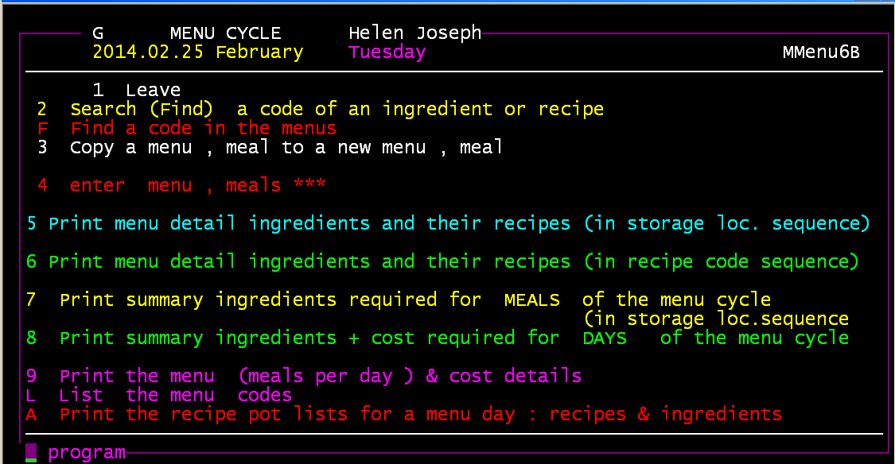

3 Copy a menu, meal to a new menu, meal
Press “page up” to move through the files
Enter spaces into ‘information’ to delete a meal
Enter the foods in codes and amounts for 100 people
e.g. ‘Apple code’, 100 menus 100 apples for that meal

Enter the recipes with no amounts (the amounts will be calculated)
Or enter a portion amount for one person
4 Enter menu, meals
Enter the individual food codes for a 100 people
e.g. Apples code, 100 means 100 apples for that meal
For day = SB08 meal: 1700 meal information DINNER
code amount,SERVE 100 code amount,SERVE 100
r TD26 0.00 SAVOURY MINCE 0.00
r TD10 0.00 SWEET POTATOES MASH 0.00
r TD20 0.00 CARROTS,STEAMED 0.00
5 Print menu detail ingredients and their recipes (Storage loc. sequence)
102 0700 BREAKFAST People = 100
5 LERATONG HOSP. 2015.10.16 October Wedesday
in storage location sequence
Number of meals entered: 1
Number of people to feed: 100
0423 BREAD WHOLEWHEAT 0.01
0731 YOGHURT GRENADILLA1L 0.01 L
2502 HAM 3.22
order: -9
3343 TOMATO,FIRM-RIPE 2.15
order: -6
WA01 WATER 14.58
order: -593
0101 ALL BRAN FLAKES 3.00 EA 01A
0111 OATS, ROLLED 1.67 kg 01B
Y to automatically update the stock quantity levels
6 Print menu detail ingredients and their recipes (in recipe code sequence)
201 0700 BREAKFAST People = 100

203 0700 BREAKFAST People = 100
6 LERATONG HOSP. 2015.10.16 Wednesday
Number of meals entered: 2
Number of people to feed: 200
3109 PILCHARDS 428G 2.50 EA ) CF02
0135 WEET-BIX EA 20.00 KG ) CF02
3723 ONIONS WHOLE PEELED KG 8.75 KG ) CF02
3321 HERBS,FRESH PARSLEY KG 0.50 L ) MIX CF02
0919 JUICE,LEMON 0.14 L ) TOG CF02
1417 WORCESTER SAUCE L 0.25 L ) CF02
0717 EGGS FRESH EA 10.00 EA BEAT) CF02
1838 SALT TABLE KG 0.01 L ) CF02
1834 PEPPER,WHITE KG 0.02 L ) CF02
3402 BEANS IN TOMATO SCE EA 4.30 EA OPEN CANS, CV02
3723 ONIONS WHOLE PEELED KG 4.06 KG CHOP, SIMM CV02
1822 MIXED HERBS 0.11 L ) ADD TOGE CV02
3302 MUSHROOM FRESH kg 4.06 KG ) TO ONION CV02
201 0700 BREAKFAST People = 100
203 0700 BREAKFAST People = 100

Y to automatically update the stock quantity levels

7 Print summary ingredients required for meals of the menu cycle (in storage loc.sequnece)
Y to automatically update the stock quantity levels

8 Print summary ingredients + cost required for DAYS of the menu cycle
Y to automatically update the stock quantity levels

9 Print menu (meals per day) & cost details
9 LERATONG HOSP. print menu meals per day from 101 to SB08
Individual foods are entered as for 100 people
Recipes amounts will be calculated from the recipe amounts
if no amount is entered else it must be entered for one portion
102 0700 BREAKFAST

SP10 OATS PORRIDGE 125
SP02 ALL BRAN 30
CV24 PLATTER:COLD HAM&TOM 50
0423 BREAD WHOLEWHEAT 100
0731 YOGHURT GRENADILLA1L L 100
1106 MIXED FRUIT, DRIED EA 4
102 0700 BREAKFAST for 100,total cost: 0.00

102 1000 SNACK
DD09 BOVRIL CAKE 100
102 1000 SNACK for 100,total cost: 0.00

L. List the menu codes
L , LERATONG HOSP. list of menu meal codes 2015.10.16
Individual foods are entered as for 100 people
Recipes amounts will be calculated from the recipe portion
1
101 0700 BREAKFAST
101 1500 SNACK
101 1700 SUPPER

102 0700 BREAKFAST
102 1000 SNACK
102 1200 LUNCH
102 1500 SNACK
102 1700 SUPPER

103 0700 BREAKFAST
103 1000 SNACK no foods in this menu meal
103 1500 SNACK
103 1700 SUPPER
Number of meals 247 over 63 days
A. Print the recipe pot lists for a menu day- recipe & ingredients
103 0700 BREAKFAST People = 100 LERATONG HOSP.2015.10.16
EGGS, POACHED
CV09 EGGS, POACHED CV09
Number of portions : 100 240
Portion description:
Portion size : 100 grams 60
sauce description:
Apparatus required :
Cooking time
Temperature
code, ------------------ purchase mass ---------------- CV09
PREPARATION:
0717 EGGS FRESH 166.667 EA PUT INTO MUFFIN PANS (50/PAN
STEAM FOR 3 - 5 MIN
PUT INTO SERVING PAN
SERVING:
SERVE 1 EGG / PORTION
E Ingredients menu
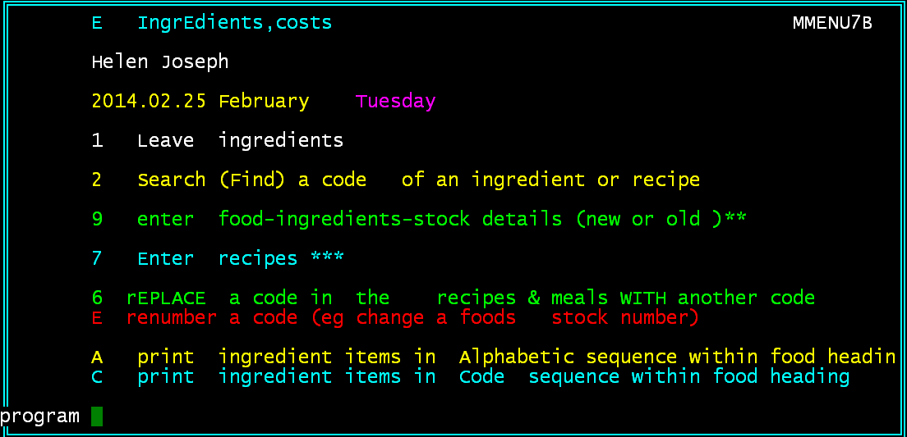

3 enter food costs

9 Enter stock details (new or old stock)

7. Enter recipes

6. Replace a code in the recipes and meals with another code

E. Renumber a code (eg. Change a foods stock number)

A print ingredient items in Alphabetic name sequence

C Print foods Code sequence
C ingredients in Code sequence within food headings
Helen Joseph n 2015.11.22 @ 17:10 page= 1
# of food headings 42 from 0101 to WA01, 01 STARCH, INCL. PORRIDGE & CEREAL
Location = item stock storage area
unit = units in which the product is purchased 1 lf = 1 loaf
P amt = Purchase quantity,amount,1lf = 16 slices/ pac6 = 6 in a pack
mass = unit mass ,1
order = items re ordering group - group items from one suplier together
bud = budget group - group similar items together within budget group
Rcost = R contract cost 2 , per purchase quantity

01 STARCH, INCL. PORRIDGE & CEREAL
name Location,unit,P amt;mass,:order,bud
0101 ALL BRAN FLAKES 500G BOX 01A EA, 1 ; 1
0105 CORN FLAKES 750G BOX 01A EA, 1 ; 1
0107 MAIZE MEAL 50KG BAG 01T kg, 1 ; 25 :GR
0108 MAIZE RICE 50KG BAG 01V kg, 1 ; 25 :GR
0109 MALTABELLA 10KG BAG 01T kg, 1 ; 10 :GR
0111 OATS, ROLLED 25KG 01B kg, 1 ; 1 :GR
0116 PASTA:MACARONI 500G 01F kg, 1 ; 10 :GR
0121 PASTA:SPAGHETTI 500 g 01F KG, 1 ; 1 :GR
0126 RICE, WHITE 50KG BAG 01V kg, 1 ; 50 :GR

8 FOOD HEADINGS
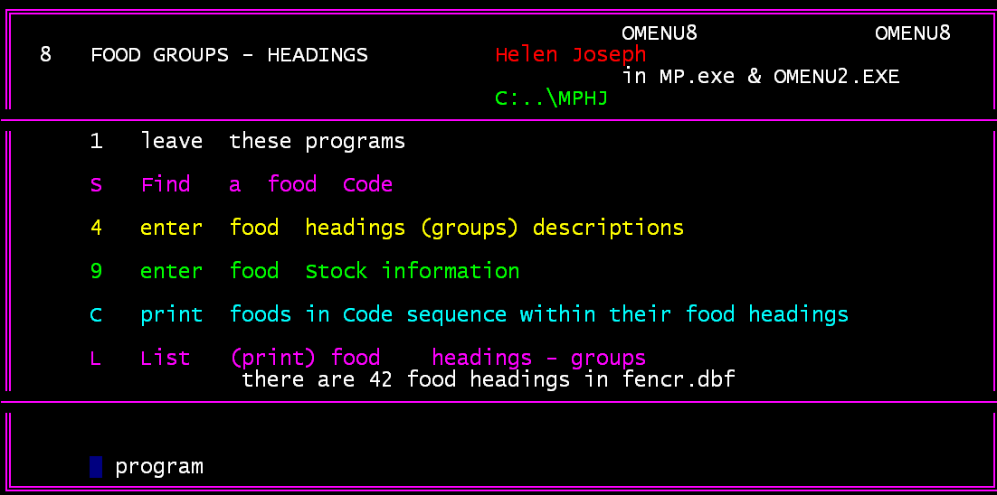

3 enter food headings (groups) descriptions

9 enter food Stock information

C print foods in Code sequence with food headings

L List (print) food Headings - Groups

See appendix 1 for list L

Installation

Before installing any program you need to, make sure all programs are closed and then
run a “Disk Cleanup” and a “Disk Defragmenter”.
This is done by:
-Click on “Start”, select “All Programs”, select “Accessories”, select “System Tools” and then
select in turn “Disk Cleanup” then “Disk Defragmenter”.
We need to create a folder (Directory) called MP on the hard disk in the root directory.
We need to copy the folder called MP from the memory stick onto your hard disk of your computer

1) We need to create an icon on your desktop, MEALPLANNER.
2) We need to enlarge the windows of MEALPLANNER.
3) we need to create an icon for 0order2.txt for printing

Method 1 (Windows 7 , Windows XP)
- Insert your MEALPLANNER CD into your cd drive.
- Click on “Start”, then select “My Computer”/”Computer”.
- Under “Devices with Removable Storage”
Right-Click on your CD drive, select “Open”.
- Right-Click on the folder “MP”, select “Copy”.
- Go back to “My Computer” and Open your Hard Disk that
has device “(C:)” in its name.
- Open the folder called “Users”.
- Right-Click on the folder with your User Name on it and select “Paste”.
- Open that same folder, and look for a folder named “MP”.
- Open the MP folder and scroll down through the Names of the files until you find a file that says “MP”.
- Right-Click the “MP” file, select “Send to”, select “Desktop (create shortcut)”.
- Close the MP Folder and go back to your Desktop.
- Right-Click on the icon on your desktop that says “MP - Shortcut”, select “Rename”, and type “MEAL PLANNER”.
- Right-Click on the same icon on your desktop that
says “MEAL PLANNER”, select “Properties”,
select the option “Change Icon”, its about halfway down the page.
- Select “OK” to the message that appears.
- Clear all the text in the box under “Look for icons in this file:”,
type pifmgr.dll into the box and press “Enter”.
- Select the “Bitten Apple” icon (Row 1, Column 2), and select “OK”.
- Open – run - “MEALPLANNER”
It appears in a Window.
- Right-Click on the Title Bar
(the bar at the top of the window with the program name in it),
select “Properties”, go down to “Font” and select “Lucida Console”, then go to “Size” and select 24. Push “OK”.
Method 2 (Windows 7 , Windows XP)

- Go to “Command Prompt”
by
- Go to “Run”
- Type CMD into “Open: ”
- Select (click) OK

or Click on Start
select “All Programs”
select “Accessories”
(look for black box icon with a blue line on top)
click on “Command Prompt”

- a black Windows should appear
- make a folder called MP by typing,
md MP and then PRESS Enter
- move into the folder MP - Change Directory
CD MP and then PRESS Enter

Should now end in c:~~~..\user???\MP
- After inserting the MEALPLANNER cd
Check on Computer
Under “Devices with Removable Storage”
what Device letter it is, D : ?

- Copy the contents of the MP folder on the CD
into the MP folder on hard disk by typing,

COPY D:\MP C: and press Enter

One would see the files being copied from the cd onto the hard drive

- Type EXIT to close and leave Command Prompt.

- We have to create an icon.
To place this icon on your Desktop for MEALPLANNER.
(the program is in the same folder – MP)
→ Click on ‘Start’, then ‘Search’, then ‘All Files and Folders”
→ In the first box type in MEALPLANNER.EXE;
Look in HARD DRIVE;
Click on ‘Search’
→ MEALPLANNER.EXE will appear: right click on this,
select ’Send to’,
then select ‘Desktop’

→ Right click the icon that says, ‘Shortcut to MEALPLANNER’:
Rename ‘Shortcut to MEALPLANNER’ to ‘Meal Planner’
→ Double click the icon to open the program:
The program now appears in a window; move the cursor onto the title bar ‘blue line’ just to the right of the program name MEALPLANNER.EXE
Right click on this title bar → select Properties:

select Font: choose Lucida Console and then size 24: click OK

Apply Properties screen appears
Go to Layout
For Window width should be 80
For Window Height should be 25
tick ‘Save properties for future windows with same title’ and click OK
Check that it works.
*********************
You are now back at the opening screen of the program:
press Enter,
then using the space bar, type spaces over the password
to take you back to the Desktop

Right click the icon again: go to Properties
→ Program → tick “close on exit” → Change Icon: choose’ Bitten Apple ‘
click OK
→ Screen: tick Full Screen(if your screen has this option)
(NOT window) then Apply
Now double click your new Bitten Apple icon to activate MEALPLANNER.

Now have a cup of coffee!

Appendix 1
L List print FOOD groups , Helen Joseph 2015.02.25
FOOD HEADINGS :42
group foods: # of foods,items
00 TUBE FEEDS & INFANT FEEDS : 37
01 STARCH, INCL. PORRIDGE & : 28
02 FATS,OILS : 10
03 BEVERAGES : 10
04 BREAD/CONFECTIONARY : 26
05 SUGAR PRODUCTS : 5
06 JAMS / SPREADS : 23
07 DAIRY PRODUCTS : 36
09 FRUIT JUICE : 14
11 FRUIT DRIED : 11
12 FRUIT TINNED : 16
13 FRUIT,FRESH IN SEASON : 21
14 CONDIMENTS : 22
15 GENERAL / MISCELLANEOUS : 33
16 FLAVOURING ESSENCE : 4
17 COLOURING ESSENCE : 3
18 HERBS & SPICES : 42
19 SEASONING MIXES : 9
20 JELLY : 9
21 PUDDING POWDERS : 2
22 SOUP POWDERS : 17
23 BEEF : 31
24 MUTTON : 11
25 PORK : 5
29 CHICKEN : 14
30 FISH : 22
31 MEAT/FISH TINNED : 10
32 MEAT , PROCESSED : 24
33 VEGETABLES FRESH : 41
34 VEGETABLES TINNED : 25
35 VEGETABLES FROZEN : 20
36 VEGETABLES DEHYDRATED : 11
37 VEGETABLES PREPREPARED : 36
38 VEGETABLES PROCESSED : 1
39 SNACK FROZEN : 2
40 ENTERAL FEEDING PRODUCTS no foods-items in 40
41 INFANT MILK FORMULAS : 1
50 DISPOSABLE ITEMS : 3
60 CROCKERY : 1
70 CUTLERY no foods-items in 70
80 EQUIPMENT : 2
90 BUY-OUT : 5
L
Number of FOOD HEADING/GROUP CODES printed= 42
Food items starting with valid headings=643
foods with wrong food headings or new headings not loaded on # 3 menu8
= 21 go to 3 menu and run # 9 to correct food codes
9 change an existing food code to another new unused food code

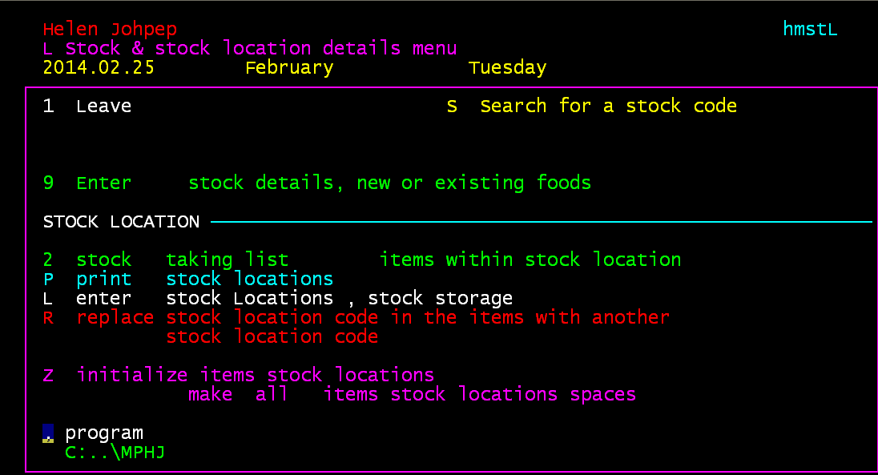

STOCK LOCATIONS STOCK SYSTEM: LOCAION AREAS-SUGGESTED

01= STORE ROOM 02= FRIDGE: DAIRY, FATS
03= FRIDGE: MEAT 04= FRIDGE: FRUIT AND VEGETABLES
05= FREEZER 06= CROCKERY STORE ROOM

01: STORE ROOM 01A = CEREALS
01B = PORRIDGE
01C = BISCUITS
01D = TINNED VEGETABLES
01E = TINNED FRUIT
01F = DRIED FRUIT
01G = FRUIT JUICE
01H = JAMS, SPREADS
01I = PUDDING POWDERS
01J = JELLY, DIET
01K = JELLY
01L = NUTS AND SEEDS
01M = DAIRY
01N = FLOUR AND STARCH
01O = SOUP POWDER
01P = DEHYDRATED VEGETABLES
01Q = SUGAR
01R = TINNED FISH
01S = TINNED MEAT
01T = BEVERAGES
01V = CONDIMENTS
01W = BAKING/GENERAL
01X = FLAVOURINGS
01Y = HERBS & SPICES
01Z = DISPOSABLES

02: FRIDGE 02A = DAIRY
02B = FATS

03: FRIDGE 03A = BEEF
03B = MUTTON
03C = PORK
03D = CHICKEN
03E = PROCESSED MEAT
04: FRIDGE 04A = FRUIT
04B = VEGETABLES, FRESH
04C = VEGETABLES, PREPREPARED
05: FREEZER 05A = FROZEN VEGETABLES
05B = FROZEN SNACKS
05C = FISH AND SEAFOOD

RECIPE CATEGORIES

MEAL PLANNER-
A = SOUP RECIPES
AP = SOUP MADE FROM SOUP POWDER
B = BREAD, PASTRIES, DOUGHS, BATTERS
C = MAIN MENU ITEMS
CF = FISH RECIPES
CM = MEAT RECIPES
CN = MINCE MEAT RECIPES
CP = POULTRY RECIPES
CS = STEW RECIPES
CV = EGGS, CHEESE AND VEGETARIAN
D = DESSERTS AND DESSERT SAUCES
F = SANDWICH FILLINGS
G = SAUCES AND GRAVIES
J = BEVERAGES
S = STARCH RECIPES:
SP = BREAKFAST PORRIDGES/CEREALS
SS = PASTA/RICE/OTHER STARCH
SV = STARCHY VEGETABLES
V = VEGETABLES (COOKED)
VS = SALADS AND SALAD DRESSINGS
.

Last page of Meal Planner Manual
MealPlannermanual.doc

