Dietetic Services
011 792 4429
CELL: 082 212 0324

E-mail: scharf@icon.co.za

www.dieteticservices.co.za

food Stock STOCK . exe

Interfaces DIRECTLY with
Meal planner MP.EXE
Or
Orders Manager OMENU2.EXE
Or
Medacc Medacc.EXE
Written in XBASE 2

Consists of one program stock.EXE
& Ten 10 data files

(COPYRIGHT RESERVED)
July 2021

Stockmanual2021.doc

Definitions 2

INSTRUCTIONS:

Password is ADMIN
Always check the date – it must be correct
00state2.txt - note the zero 0
Always close 00state2.txt on the Desktop
so that it may be overwritten with the new information

Always check next to the start button that the program is closed

Always close the program when not in use

a1. ALWAYS READ THE SCREEN & ANSWER THE SCREEN MESSAGES.
b2. When starting for the first time - GO SLOWLY through the system.
Speed will be gained with experience.
c3. "Enter": press after a value/name has been entered –
to move to the next field or screen.
d4. All information, Eg names, should be entered in UPPER CASE (CAPITALS).
e5. NO PUNCTUATION MARKS MUST BE USED (Eg no commas,/full stops.)
f6. Printouts are printed on A4 size paper
g7. Always have a spare printer cartridge available.
Always have enough paper.
h8. NEVER SWITCH OFF the computer before leaving all programs.

INSTALLATION ONTO HARD DISK C:
The folder ..\STOCK , ..\MP or ..\Medacc is normally used
WINDOWS XP,7 ,8,10
The program Stock.EXE – your “ STOCK” must be in folder ..\MP.
Click on All Programs – accessories – select Command Prompt
OR Go to RUN and type in CMD
a. Make a FOLDER (directory) named ..\stock
MKDIR STOCK (press "Enter")
b. CHANGE to the FOLDER STOCK
CD STOCK (press "Enter")
c. COPY the information into folder STOCK
COPY D:\STOCK *.* (press "Enter")
copy D:\STOCK\star dot star
(Always do a backup before loading new versions)
(Select "A" for "overwrite All" – for previous users)
Type EXIT to leave command prompt & return to Desktop.
e. Store this backup DEVICE
f. TO RUN:
CD STOCK
Type STOCK.EXE and press "Enter" to start the program

g. To Create an icon for STOCK.EXE on your WINDOWS Desktop 3
Click on START
Go to FIND (OR SEARCH)
Go to Files or Folders
In Named: type in the words: STOCK.EXE
Look in C:
Click on Find now
- STOCK. EXE should now appear in the column “Name”
Right click STOCK.EXE – go down to Send to – select Desktop (create shortcut)

Close the “search “– find window
Go to desktop
Right click on the icon: Shortcut to STOCK.EXE
Go to Properties
Go to Program
Select Close on exit; also change the icon and click Apply
Click on Screen and select Close on exit
Rename “Shortcut” to STOCK FOOD

h. Your password is "ADMIN”
use Caps Lock on & stay in Capitals

Starting for the first time

1 You would have to get a list of the food headings
Menu 8 number L list food headings

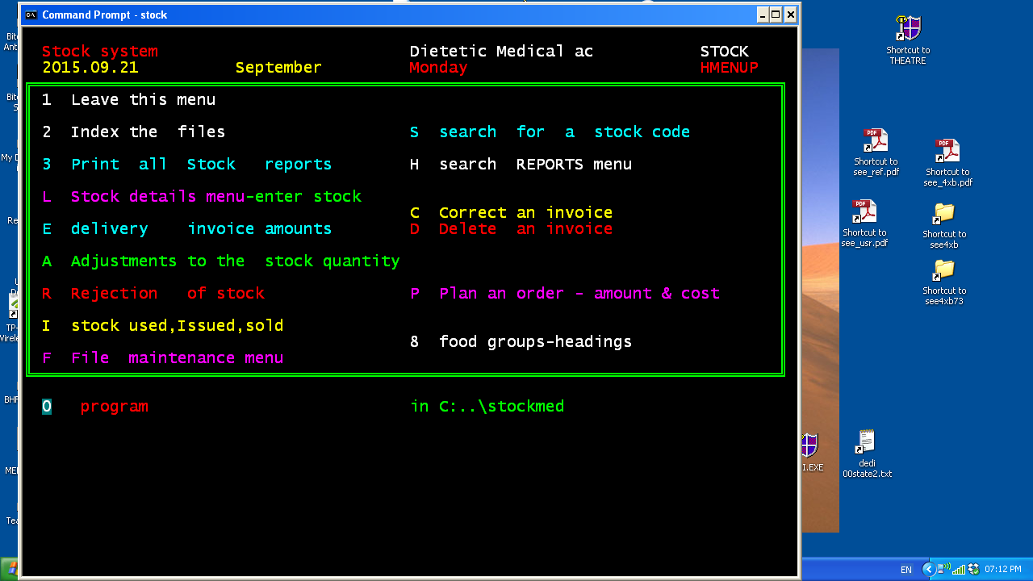

Starting for the first time

The STOCK SYSTEM consists of a screen (menu) from which other screens (menus) may be selected, by entering the relevant number and pressing enter.

DEFINITIONS:

INGREDIENT=STOCK item=food
A food item (stock item) that can be added to a recipe OR used separately in a
meal/menu.
Stock items also refer to enteral feeding products, and also to disposable items, such as paper bags, plastic wrap etc.

DELIVERY INVOICE
The invoice that is handed over on delivery of goods to the kitchen by the supplier. Each invoice has its own number, and the items delivered are listed with unit costs/item and the total costs indicated.

AUDIT
Track record of stock items (usage/rejections/delivery)

PURCHASE UNIT
The units in which ingredients/stock items are purchased.
For the purposes of this program: kilograms= KG e.g. meat
Liters=L e.g. milk
Each= EA e.g. apple

PURCHASE MASS
The mass of the ingredients to be purchased expressed in the specified purchase units.

STOCK STORAGE LOCATION AREA
Area of the kitchen (eg pantry/fridge) where a stock item is stored.
This is used for stock taking purposes.

GENERAL PROCEDURE:
To enter the stock system, first enter the password: ADMIN
1 To LEAVE the stock system programs
and return to your windows desktop: select 1 and then Enter
2 INDEX ALL THE STOCK SYSTEM FILES: select no. 2
- These files are then indexed for computer usage
- This program automatically fixes many problems which can occur,
to reduce down time and to allow telephonic support
- This is a major time and cost saving feature of the system
- Should there be any problems, use this program
- Use this program as often as you wish

SUMMARY OF PROCEDURE TO BE FOLLOWED:

- Enter STOCK details
- DAILY: enter stock issued, rejected, delivered
- STOCK-TAKING (daily/ weekly/fortnightly/monthly etc)
- BACKUPS

PROCEDURE

1) STOCK DETAILS: S

- All stock details are entered here.
- Currently >? items are already loaded

VIEW/UPDATE STOCK DETAILS

Note: Stock is coded as follows:
The first 2 digits indicate the FOOD GROUP HEADING, with the second 2 digits specifically designating each stock item with its own number within a food group.

FOOD GROUP HEADINGS- See appendix I

Examples of food group headings:
02 corresponds to FAT
07 corresponds to DAIRY PRODUCTS

Ingredients are then numbered according to the specified food group heading (See below)

Example of an ingredient code: CONDENSED MILK: 0722
(07 corresponds to the food heading group: DAIRY PRODUCTS)

  - Print the list of stock in STOCK CODE SEQUENCE:
Select 3 from the main menu, program C
Decide on codes to be deleted /added

Now select S from the main menu

  - Print the list of STOCK LOCATIONS
Correct and update your own list to suit your specified situation: L
Now print out a new list.
P – Refer to this list when entering in your stock details.

  - DELETE any stock codes not used (ONLY IF REALLY NECESSARY)
S – Go into the code and type spaces over the description.

Tip: It is advisable to leave most codes on the file (you never know when that item might become available/necessary, e.g. for functions)

  - ADD new stock codes: # L , # 9
Decide on code number (the first 2 digits indicate the FOOD GROUP HEADING, and the second 2 digits follow on from the last number used- see code list)

Type in the new code and its description

  - UPDATE ALL STOCK DETAILS: S
Type in the following for each ingredient:

-Package size
-supplier
Stock storage location area (refer to list)
-Minimum stock quantity (reqd. in stock)
-Cost per purchase unit
-Contract cost per unit
-Purchase unit (NB: IN KG/L/EA)
-Purchase mass
-Conversion factor (if using EA for each, to KG or L) E.g. 1 apple=0.12KG

  - If required, print the new list of stock in code sequence-using 3 from the main menu,
Program no. C, OR A to print the stock alphabetical name sequence.
It is not essential to print out this list. Another way of finding a stock code is in:
Main menu, program number S
Menu L, program number S
Menu H, program number S

  - To change a stock code, use Menu L program C

2) INITIAL STOCK TAKE: A

2.1) Print a stock taking list: Menu 3, number 2
(This prints out in stock location order)
2.2) Manually count all stock –fill in on this list

2.3) Now select program A from the main menu:
-Type in each stock code (start with the first one,
then use the Page up/down keys to move through the files in the same order as on your stock-taking printout)
-Enter in the counted stock amount.

3) DAILY PROCEDURE: E, I, R

E: Stock items are delivered and checked against their deliver invoices.
(Check that stock deliver was actually ordered,
and that it matched up to the quality specifications)
These invoices should be collected during the day,
and then at a specific time each day
(Eg between 1-2pm).
This information is then typed into the computer into this program E
Procedure: Code each item on the invoice using program number 4
Go into E- type in invoice number, supplier, and total cost of invoice,
food codes and the quantity delivered with its Rand value.
Once the invoices are typed in, the computer then automatically updates the stock file.

If necessary, these invoices can be corrected OR deleted, using C or D.

I: Stock items issued are coded and entered here- the stock file is then automatically updated.

R: Stock items rejected (rotten/sour etc) are entered here (again the stock file is automatically update)

- REPORTS: 3

STOCK TAKING

2 STOCK TAKING LIST
This list is printed out in stock storage location order.
Stock items and their codes are listed.
Fill in the stock-quantity manually, and the adjust these amounts in program A (main menu)
(Any discrepancies between stock counted
and the stock quantity indicated on the computer must be accounted for.)

L CONTROL LIST STOCK ISSUED,DELIVERED
a list that can be printed daily.
A supervisor can use this list (also printed in stock storage location order) to fill in the daily issues and deliveries- and then to transfer this information daily onto the computer-
thus updating the computers stock files.

- STOCK FILE
This report lists all information entered in programs S, E, A, R, I (main menu) per stock item.
A total quantity of amount of stock used LAST month,
and the quantity used month-to-date is also displayed.

- STOCK-ON-HAND AND VALUE
This report lists current stock-on-hand and its total Rand value.

- AUDIT MOVEMENTS OF A STOCK ITEM
This report lists all movements of a SINGLE STOCK ITEM: ie amounts purchased and delivered, issued and rejected, as well as the amount currently in stock.

If the stock quantity on hand is not the same as the actual stock then this program can be used to help account for the missing amounts.

- SLOW MOVING STOCK
Infrequently used stock items are indicated in this report.
One can then easily determine whether certain items should ever be purchased again
(not a popular menu item?), or if one should check the shelf –life of the other infrequently used items (maybe used once a year for a specific function)

- LOSS REGISTER
This report lists any stock items, their quantities and Rand values- as well as a total Rand value- that have been lost/rejected, over a set period of time determined by the user.

D DELIVERY INVOICES
All stock items delivered over a predetermined time period: Quantities and costs are displayed.

F INFLATION IN FOOD COST
Food costs, both old and current, and this the inflation for all food items over predetermined time period are displayed.

*************************************************************************
H Search for REPORTS: H
See screen summary: programs are self-explanatory.
Decide on the report required- and select the relevant program.
**********************************************************
F FILE MAINTENANCE

H Backup of the data should be done daily, and the backup memory stick stored in a safe place.

Z Restore of the data is only done if the programs must be copied onto a new hard disk or computer.
Contact Rand Software before carrying out this procedure.

- Leave this menu
Takes you back to your windows desktop.

- Index the files
Run this program whenever you feel like it or when there is a problem.

- Print all stock reports
Takes you to another menu. (See pages below

L Stock details menu
Takes you to enter stock details. (See pages below)

E Delivery invoice reports
Here you enter the suppliers invoice details, so your stock levels can be updated.

A Adjustment to stock quantity
Use this program to correct the stock quantity after a stock take or during the month.

R Rejection of stock
Rejection of stock already, received and entered.

I Stock issued used
Daily usage of stock is entered here, that is subtracted from stock on hand.

F File maintenance menu

S Search for a code on the file
e.g. for beans code , enter BEANS
Enter spaces into the food to leave this program
BEAN
Enter the food RICE

s,Finding RICE Cost Qty unit,Stock location
0108 MAIZE RICE Q: -8 02A
0124 RICE CRISPIES Q: 7 01A
0126 RICE, WHITE 01J
1912 SAVOURY RICE FLAV. 02G
Press any key to continue...

H Search reports menu
(See pages below)

C Correct an invoice
D Delete an invoice
You enter the invoice number and enter the date of the invoice.

P Plan an order, meal
It allows a food service manager to design a meal and works out the quantities and the cost.

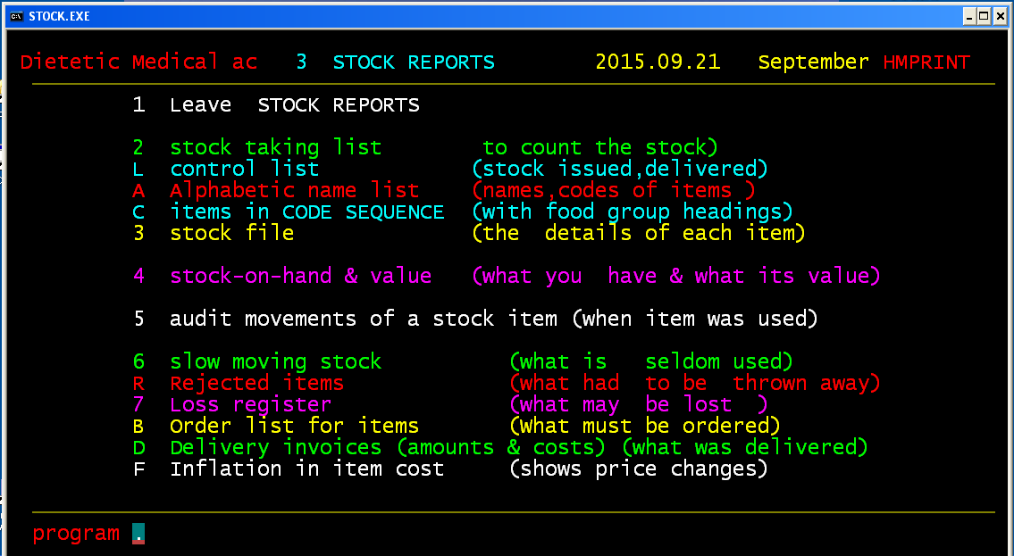

- Stock taking list
This application counts the stock that has been entered into the computer.

L Control list
It records the stock that has been issued as well as the stock that has been received (delivered).

A Alphabetic name list
It shows the names of the item/food as well as the code of each respective item in alphabetical order.

C Food in code sequence
It shows the code order sequence of the food items as well as the group headings.

- Stock file
It shows all the details of each item that has been entered into the database.

- Stock on hand & value
It shows what you have in stock and what the value of the stock is worth.
- Audit movements of stock item
It allows you to view when an item was last used, thereby enabling you to identify slow moving stock.

- Slow moving stock
This is stock that is rarely used.

R Rejected foods
This is a list of all the stock items that should be discarded.

- Loss register
This enables you to record what is lost and to view how many items have been lost.

B Order list of foods
This enables you to view what is low in terms of stock and therefore what you need to order.
B CULLINAN CARE,REHAB Order list 2011.10.10 PAGE 1
ORDERS WILL BE CALCULATED FROM 'STOCK MINIMUM' MINUS 'STOCK ON HAND'

9005 GINGER PRESERVED EA
in stock: 0.000 Minimum: 100.000 Order:100

D Delivery invoices
The amounts and the costs of what was ordered,
as well as a record of what was delivered on different dates.

F Inflation of food costs
Shows the price lists and their respective changes.

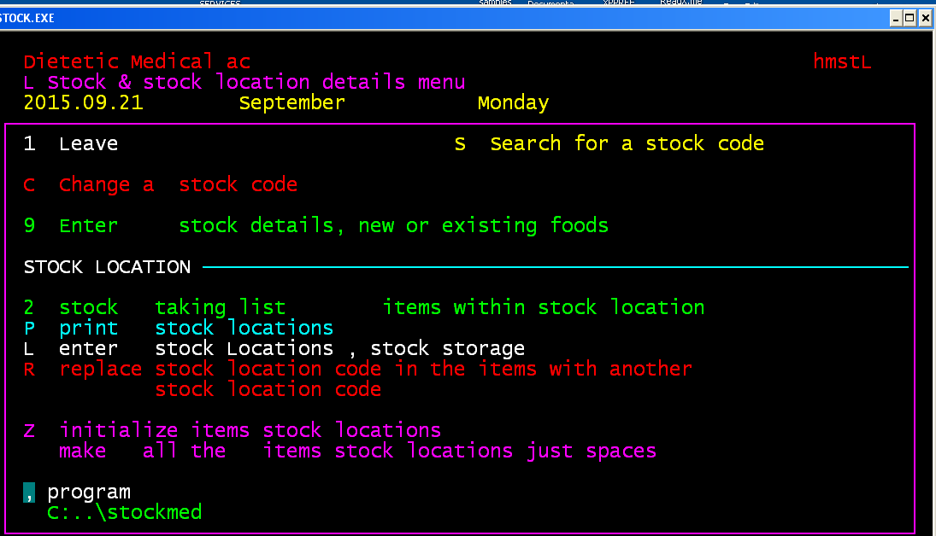
s s,Search for a code on the file
Enter spaces into the food to leave this program
Enter the food RICE
4,Finding RICE Cost Qty unit,Stock location
0108 MAIZE RICE Q: -8 02A
1912 SAVOURY RICE FLAV. 02G
C Change a stock,food code
This enables you to change an existing stock,food.item code to a new one.
Change a stock code to an unused new code.
NB- You may not use this program if your system has recipes.
9 Enter stock food item details
This enables you to enter details that involve new/existing foods , stock.
L Enter stock locations
This enables you to specify what the stock location is.
E.g. Stock storage location; 01A Cereals for all cereals
P Print stock locations
This is where you can print the storage locations as needed.
P STOCK LOCATIONS 2011.10.10
stock description # of items
01A CEREALS 01A = 6
02E NUTS & SEEDS 02E no items
NUMBER OF STOCK LOCATIONS PRINTED 2
Your stock taking list is printed with foods,items,
Grouped in stock location sequence.

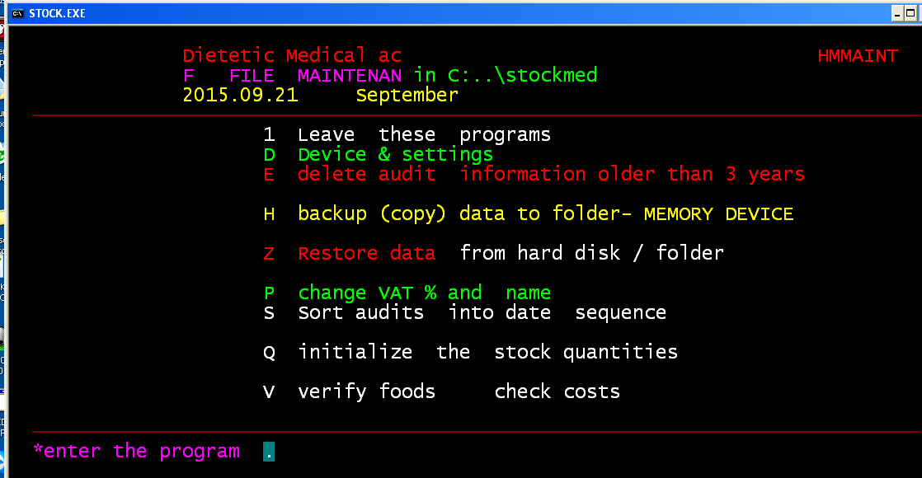

D Device and settings
D Device settings- memory- E, F, G & printers- M
V Clean folder
Run this program whenever you want to.
P OFPAR FFPAR
Allows user to change the name of the
E Delete audit information older than 3 years
This allows you to delete any information that is older than 3 years.
h Backup (copy) data to a folder
This is used to create a copy of your information in case your primary information is lost.
Z Restore data from hard disk/folder
This allows you to copy information from a hard disk onto your computer system.
P Change VAT % and other parameters
This enables you to change any VAT or cost related parameters to the economic environments.
S Sort audits into date sequence
This sorts your audits into a dated sequence.
C Check suppliers name
This enables you to verify suppliers’ names and details
M Check minimum stock quantity
You can use this program to check that you have the minimum stock required and will enable you to see what stock needs to be ordered.
Q Initialize the stock quantities
This program is used if a mistake is made and you would to start again or if you are a new .
V Verify foods, check costs
This allows you to verify the food cost details that relates to the storage location, the unit purchased and the amount

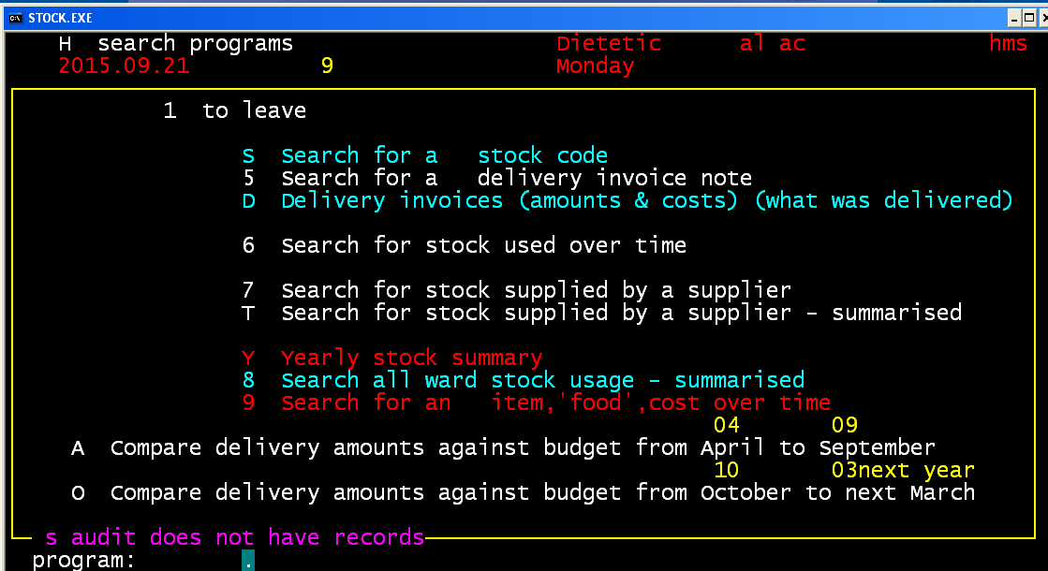
S Search for stock code
This allows you to search for a stock code.
5 Search for delivery invoice note
This enables you to look for proof that the delivery was received.
D Delivery invoices
This is the amounts that where delivered as well as their costs and what items were delivered.
- Search for stock used over time
This shows you the stock that was used over a certain period of time.

- Search for stock supplied by a supplier
This shows what stock was received from different suppliers.

T Search for stock supplied by a suppler- summarised
This shows a summary different stock that was supplied by different suppliers.

Y Yearly stock summary
This shows what stock was used and how much of this stock was used in 1 year.

- Search for all ward stock used- summarised
This is a summary of all the stock that was used in the wards and presents it in a summarized form.

- Search for an item, ‘food’, cost over time
This shows you the cost of a selected food over a period of time.
A Compare delivery against budget from April to September
This allows you to compare the budgeted costs against the actual costs between April and September.
O Compare delivery amounts against budget from October to next March
This allows you to compare the budgeted delivery costs against the actual costs between October and March.

APPENDIX 1
***********
L List print FOOD groups , LERATONG HOSP. 2011.10.18
group foods: # of items
00 TUBE FEEDS & INFANT FEEDS : 34
01 STARCH, INCL. PORRIDGE & : 25
02 FATS,OILS : 7
03 BEVERAGES : 6
04 BREAD/CONFECTIONARY : 19
05 SUGAR PRODUCTS : 4
06 JAMS / SPREADS : 17
07 DAIRY PRODUCTS : 28
09 FRUIT JUICE : 14
11 FRUIT DRIED : 12
12 FRUIT TINNED : 14
13 FRUIT,FRESH IN SEASON : 16
14 CONDIMENTS : 12
15 GENERAL / MISCELLANEOUS : 28
16 FLAVOURING ESSENCE : 3
17 COLOURING ESSENCE : 3
18 HERBS & SPICES : 37
19 SEASONING MIXES : 5
20 JELLY : 8
21 PUDDING POWDERS : 1
22 SOUP POWDERS : 14
23 BEEF : 24
24 MUTTON : 6
25 PORK : 5
29 CHICKEN : 6
30 FISH : 15
31 MEAT/FISH TINNED : 9
32 MEAT , PROCESSED : 19
33 VEGETABLES FRESH : 37
34 VEGETABLES TINNED : 19
35 VEGETABLES FROZEN : 15
36 VEGETABLES DEHYDRATED : 9
37 VEGETABLES PREPREPARED : 33
38 SNACK FROZEN : 2
40 ENTERAL FEEDING PRODUCTS no foods-items within group 40
41 INFANT MILK FORMULAS : 1
50 DISPOSABLE ITEMS : 3
60 CROCKERY : 1
70 CUTLERY no foods-items within group 70
80 EQUIPMENT : 3
90 BUY-OUT : 5

Number of FOOD HEADING/GROUP CODES printed= 41

STOCK LOCATIONS STOCK SYSTEM: LOCAION AREAS-SUGGESTED
01= STORE ROOM 02= FRIDGE: DAIRY, FATS
03= FRIDGE: MEAT 04= FRIDGE: FRUIT AND VEGETABLES
05= FREEZER 06= CROCKERY STORE ROOM

01: STORE ROOM 01A = CEREALS
01B = PORRIDGE
01C = BISCUITS
01D = TINNED VEGETABLES
01E = TINNED FRUIT
01F = DRIED FRUIT
01G = FRUIT JUICE
01H = JAMS, SPREADS
01I = PUDDING POWDERS
01J = JELLY, DIET
01K = JELLY
01L = NUTS AND SEEDS
01M = DAIRY
01N = FLOUR AND STARCH
01O = SOUP POWDER
01P = DEHYDRATED VEGETABLES
01Q = SUGAR
01R = TINNED FISH
01S = TINNED MEAT
01T = BEVERAGES
01V = CONDIMENTS
01W = BAKING/GENERAL
01X = FLAVOURINGS
01Y = HERBS & SPICES
01Z = DISPOSABLES

02: FRIDGE 02A = DAIRY
02B = FATS

03: FRIDGE 03A = BEEF
03B = MUTTON
03C = PORK
03D = CHICKEN
03E = PROCESSED MEAT
04: FRIDGE 04A = FRUIT
04B = VEGETABLES, FRESH
04C = VEGETABLES, PREPREPARED
05: FREEZER 05A = FROZEN VEGETABLES
05B = FROZEN SNACKS
05C = FISH AND SEAFOOD

RECIPE CATEGORIES

MEAL PLANNER- RAND SOFTWARE

A = SOUP RECIPES
AP = SOUP MADE FROM SOUP POWDER
B = BREAD, PASTRIES, DOUGHS, BATTERS
C = MAIN MENU ITEMS
CF = FISH RECIPES
CM = MEAT RECIPES
CN = MINCE MEAT RECIPES
CP = POULTRY RECIPES
CS = STEW RECIPES
CV = EGGS, CHEESE AND VEGETARIAN
D = DESSERTS AND DESSERT SAUCES
F = SANDWICH FILLINGS
G = SAUCES AND GRAVIES
J = BEVERAGES
S = STARCH RECIPES:
SP = BREAKFAST PORRIDGES/CEREALS
SS = PASTA/RICE/OTHER STARCH
SV = STARCHY VEGETABLES
V = VEGETABLES (COOKED)
VS = SALADS AND SALAD DRESSINGS
.

End of stockmanual2021.doc

